**Smart Gardening App** (**SGA**) based on NODE MCU and smart phone device using internet. The main objective of the smart plantation is to provide comfortable, a convenient user interface by sensing and controlling plant environment. This figure shows the system architecture of SGA which consists of NODE MCU, Temperature sensor, Humidity sensor, pump, LDR sensor , Relay circuit, Android application.

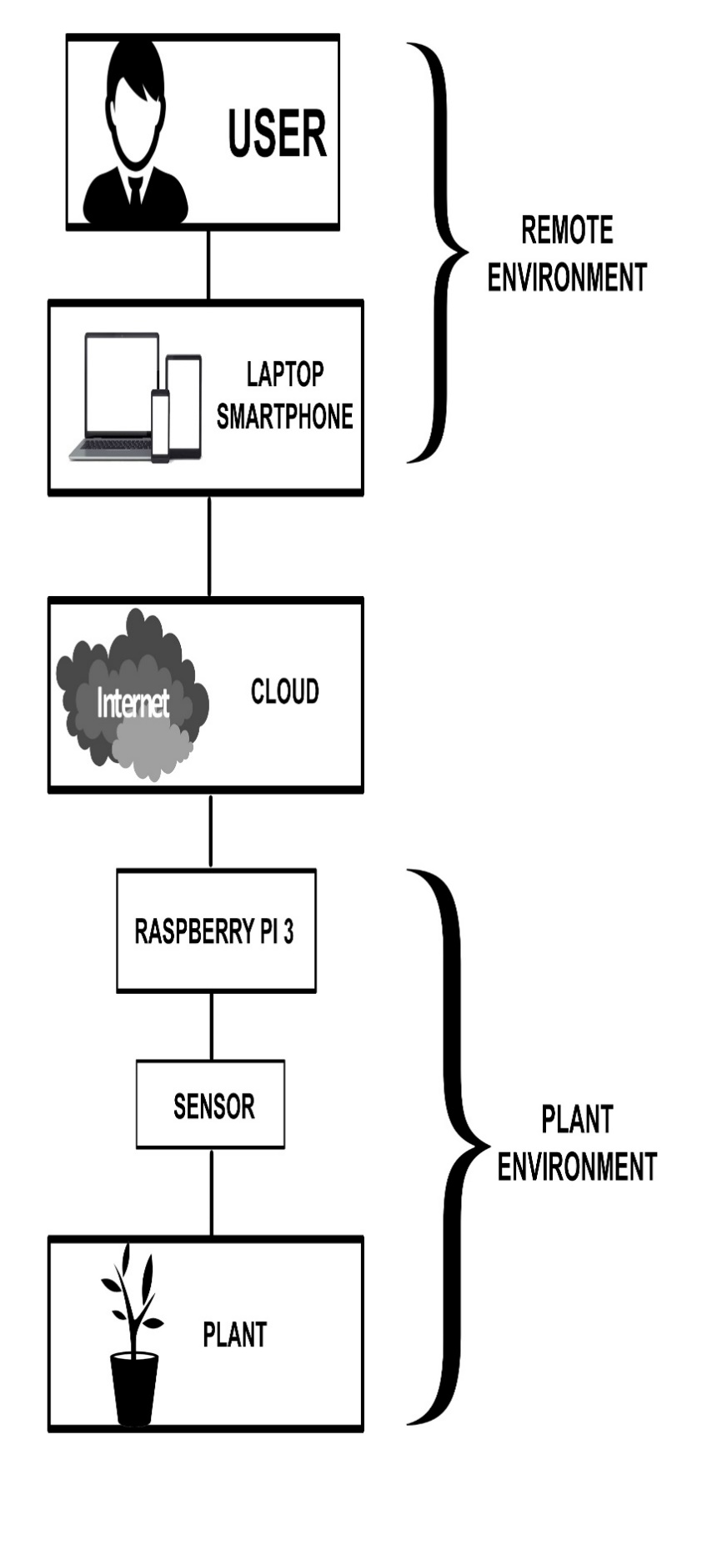

**SENSORS:**

Sensors are the devices which converts the physical parameter into the electric signal. Our system consists of the following sensors.

* **Soil moisture sensor :-** used to measure the moisture content of the soil.

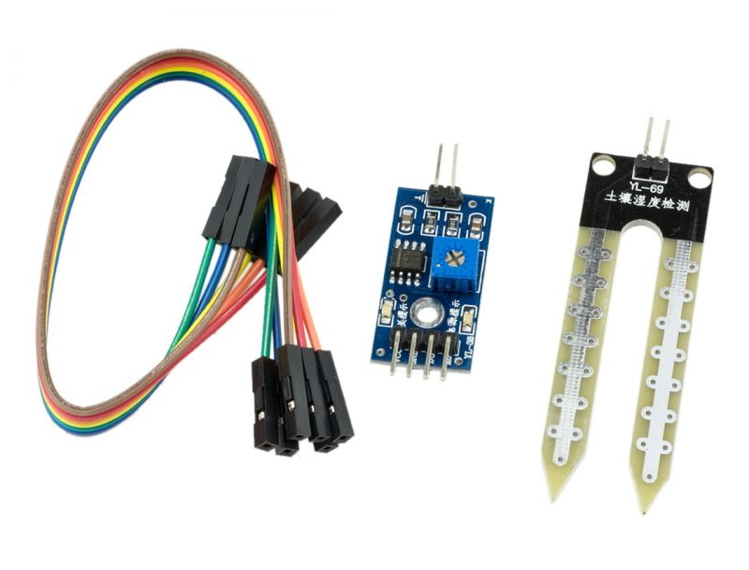

* **LDR (Light Dependent Resistor) :-**  used to detect the variation in intensity of the light.

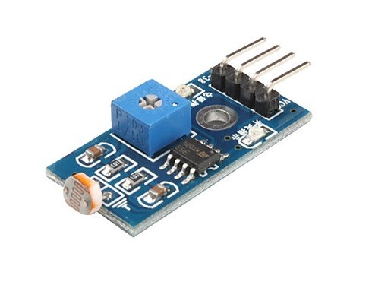

* **Temperature and Humidity sensor :-** used to keep track of temperature and humidity in plant environment.

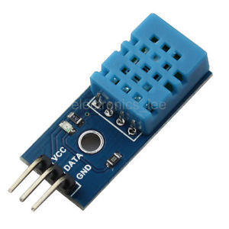

**NODE MCU :**

Node mcu an open source IoT platform. It is the integrated version of the popular ESP8266, a Serial to Wi-Fi System On a Chip (SoC). The ESP8266 was developed by the Shangai-based company [Espressif Systems](http://espressif.com/products/hardware/esp8266ex/overview/), an IC manufacturer focused on the development of RF chips, particularly Wi-Fi.

There are several modules in the market that use the ESP8266 chip, they are named ESP-NN, where NN is a number 01, 02,……..12, sometimes followed by a letter. These modules typically carry the ESP8266 SoC, flash memory, a crystal, and in most cases, an onboard antennaThe 2 more important modules are without doubt, the ESP-01 and the ESP-12E.

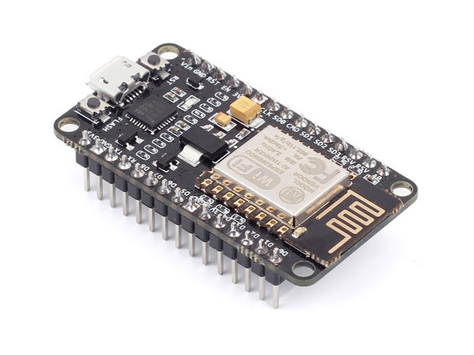

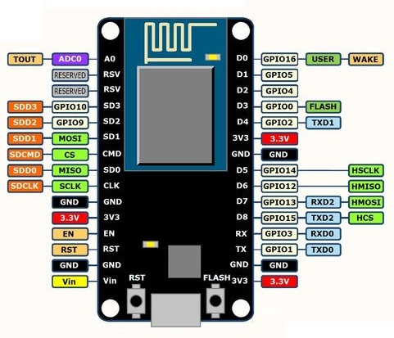

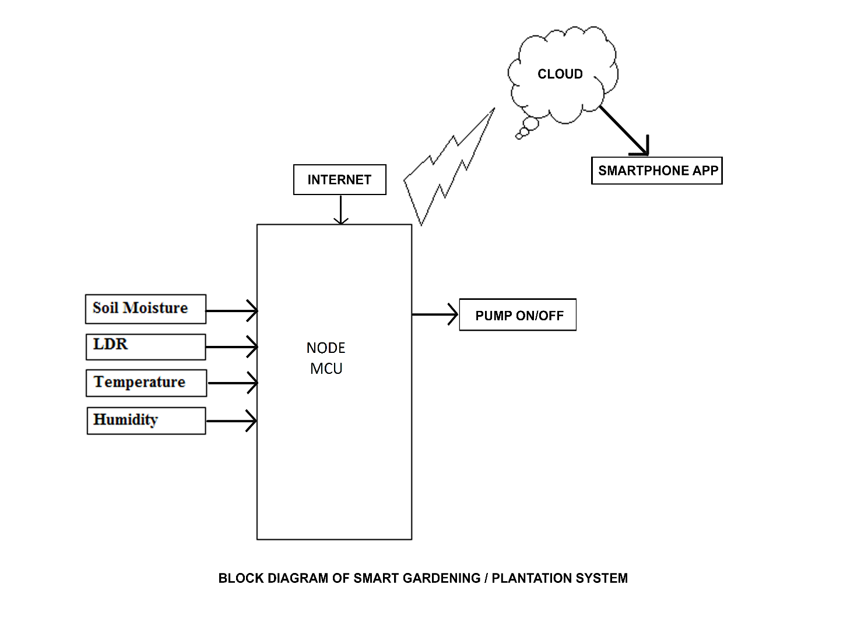**EXPLANATION**

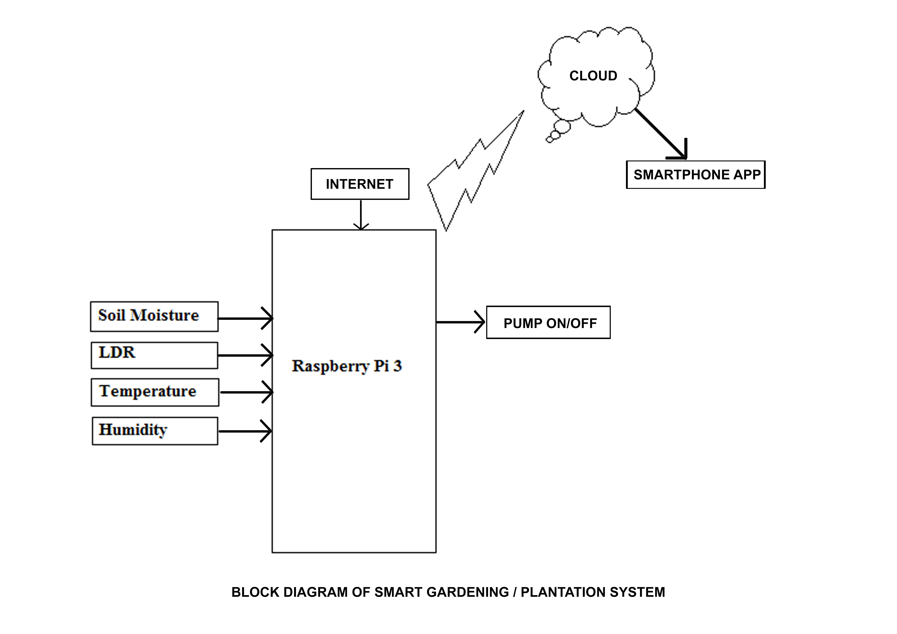

Based on various analog readings from above mentioned sensors, we transfer all this data to our respective cloud based platform through the NODE MCU. Later on, by doing various processing on the data obtained from the cloud on our respective client web page/app we can obtain the regular updates and growth trends for our plant. By using this system, we can never overwater or underwater our plant because of the controlled

water pump through soil moisture sensor. Also, we can see what all plants we can grow in the soil available to us by putting our sensors, along with our the global location. Moreover by collecting some proper data set, we can perform some sophisticated machine learning algorithm that could greatly automate all our tasks and manage everything effectively.